DETAILS OF COMPLETED MPCS UNDER NCRMP WORK
Sl. No. | Name of the District | Name of the Cyclone Shelters | Photographs of the MPCS
1 | Bhadrak | Artung | 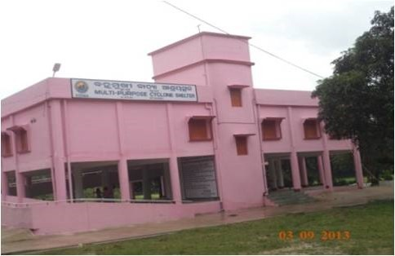
2 | Bhadrak | Balarampur | 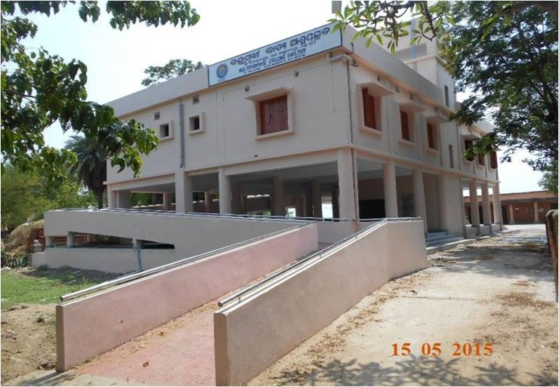
3 | Bhadrak | Kaduanasi | 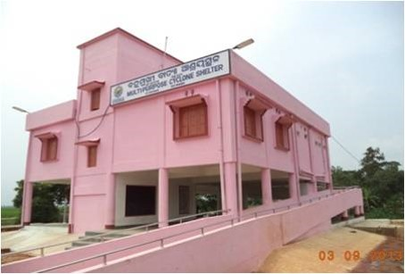
4 | Bhadrak | Ankapada | 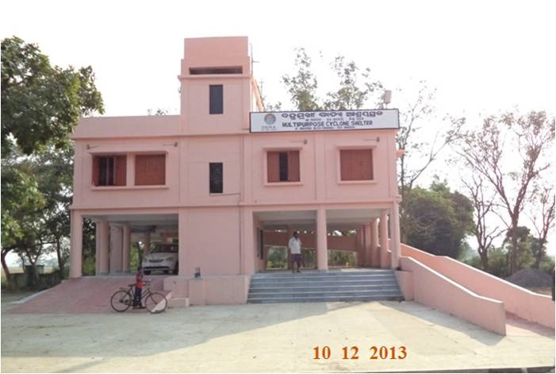
5 | Bhadrak | Biriadia | 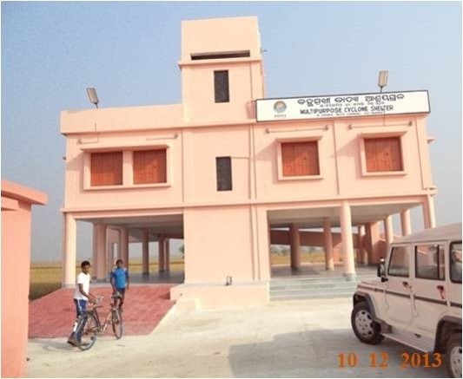
6 | Bhadrak | Sunaripokhari | 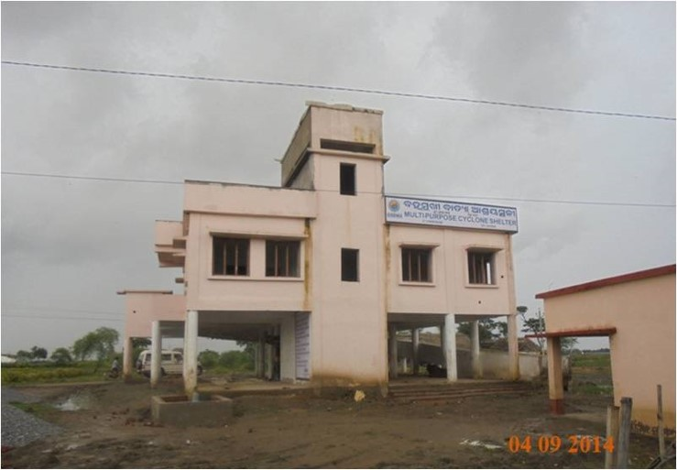
7 | Bhadrak | Nachhipur | 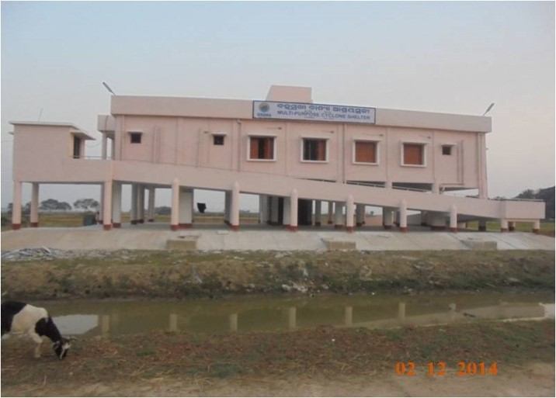
8 | Bhadrak | Utarasahi | 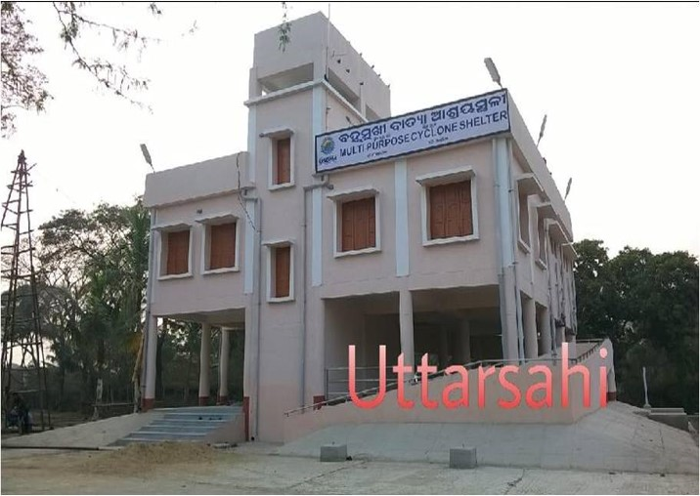
9 | Bhadrak | Barakhola | 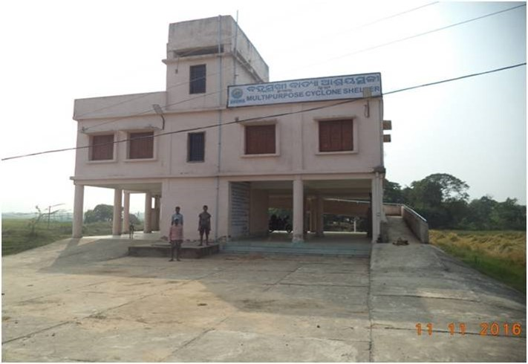
10 | Bhadrak | Jantuali | 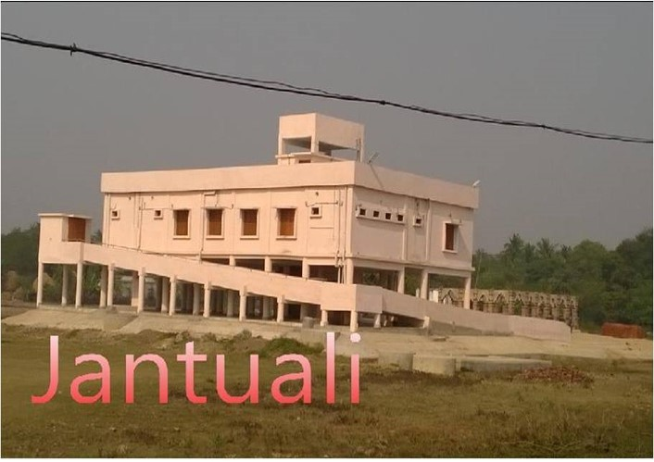
11 | Bhadrak | Baliarpur | 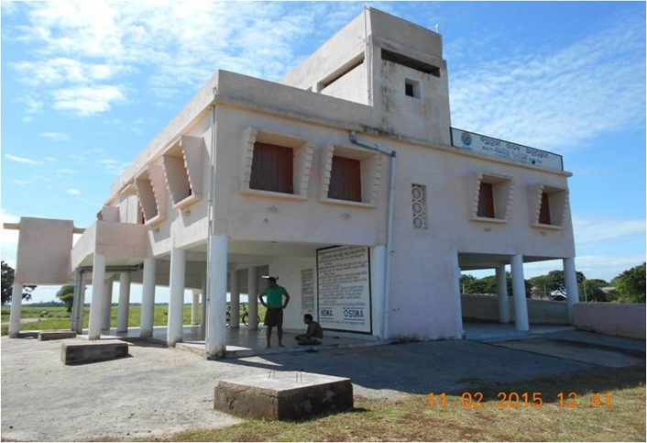
12 | Bhadrak | Khedualpur | 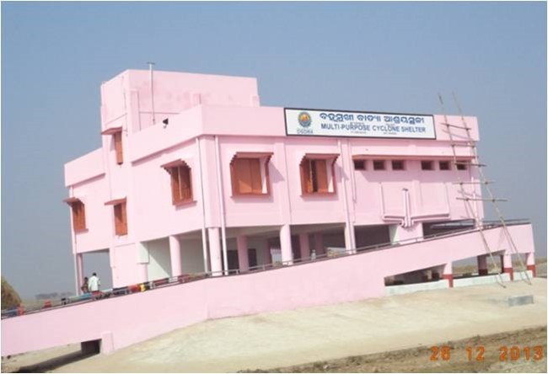
13 | Bhadrak | Adhuan | 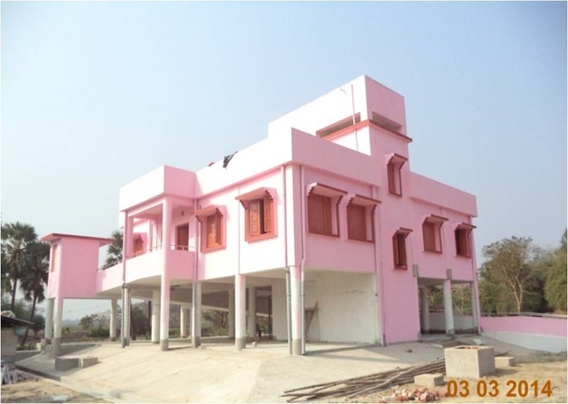
14 | Bhadrak | Sarapokhari  (Padhuan) | 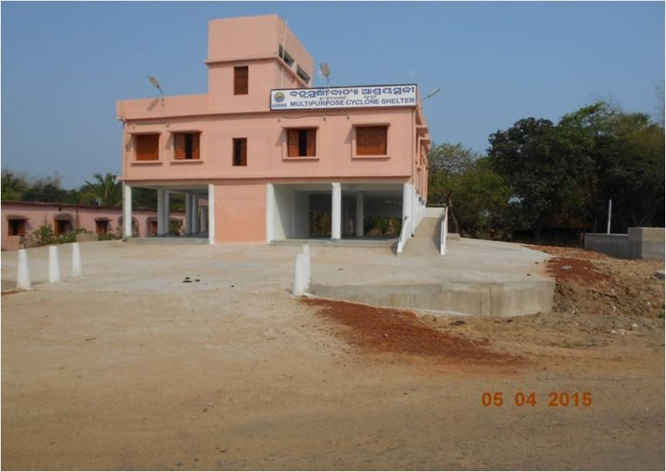
15 | Bhadrak | Khadalpokhari | 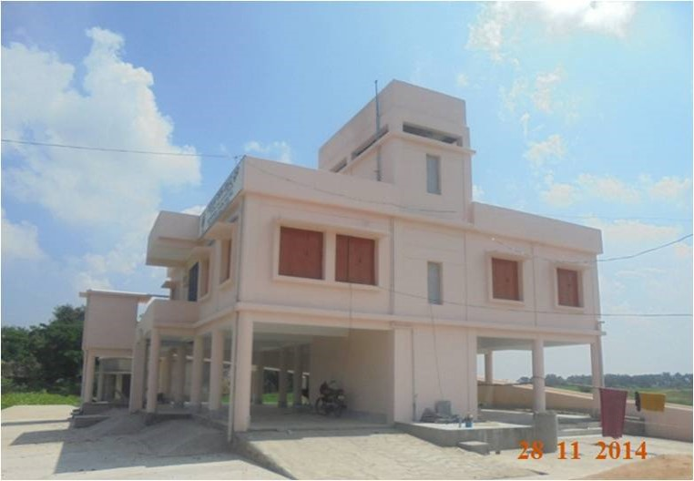
16 | Bhadrak | Sana Chandanipal | 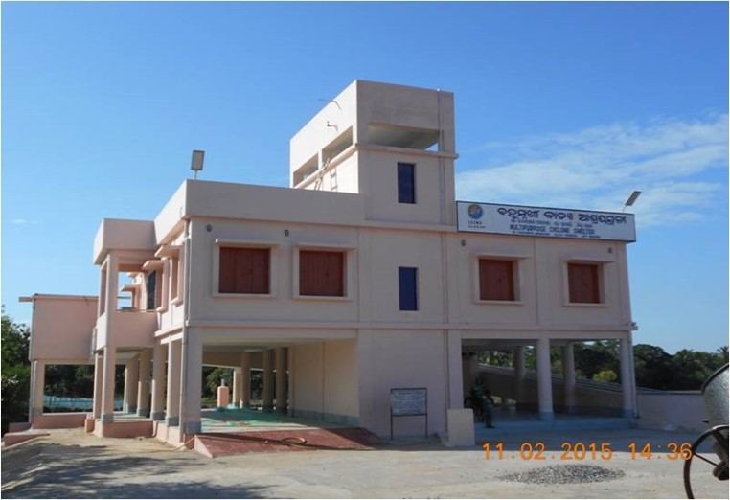
17 | Bhadrak | Kasia | 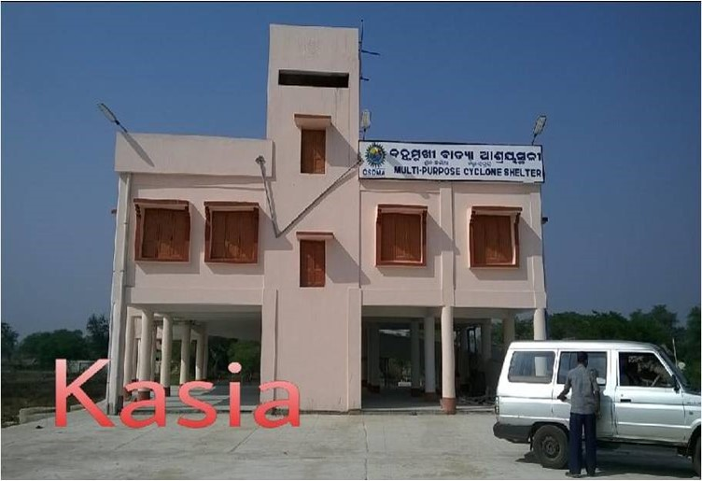
18 | Balasore | Bolanga | 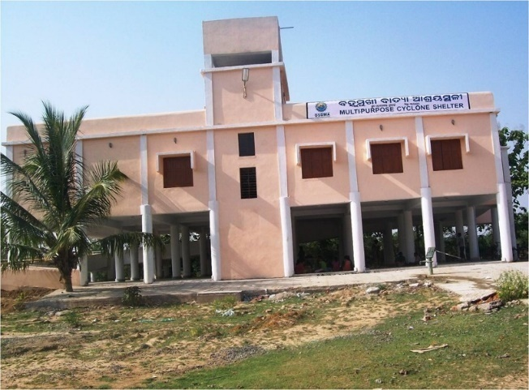
19 | Bhadrak | Badamahara | 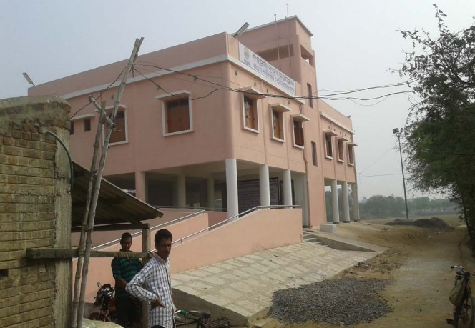
20 | Bhadrak | Bideipur | 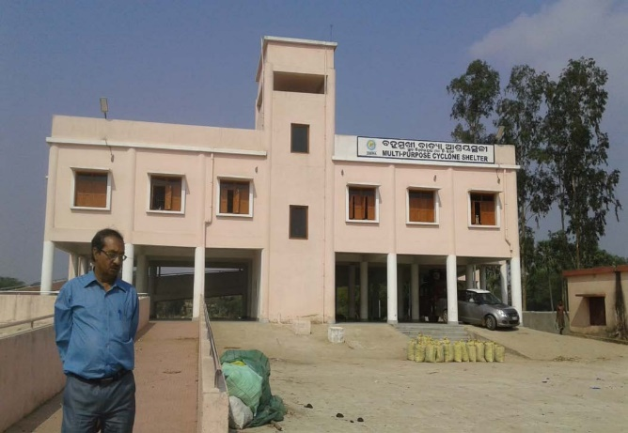
21 | Bhadrak | Sanakrushnapur | 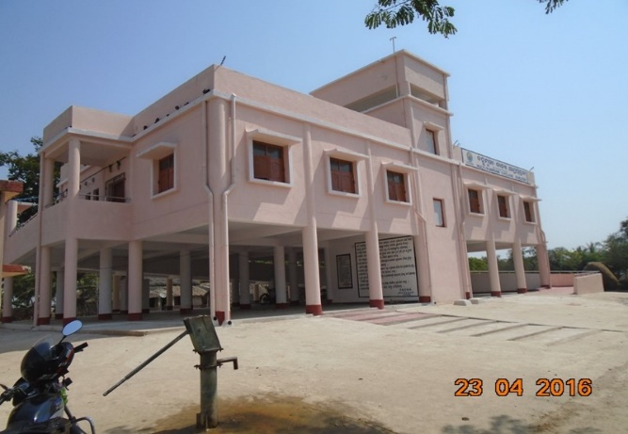
22 | Bhadrak | Kismatkrushnapur | 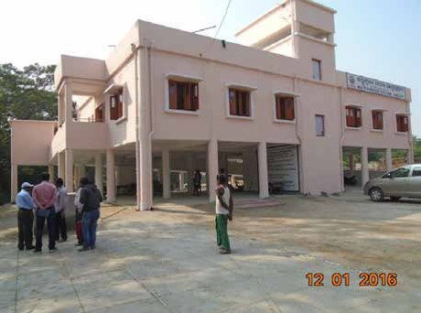
23 | Bhadrak | Chhedak | 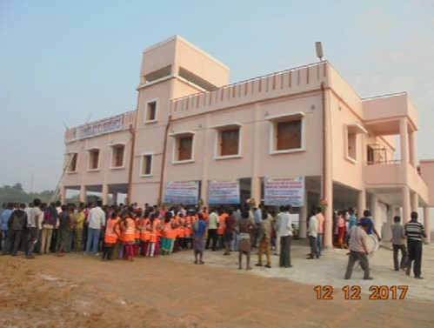
24 | Bhadrak | Bidyutprava | 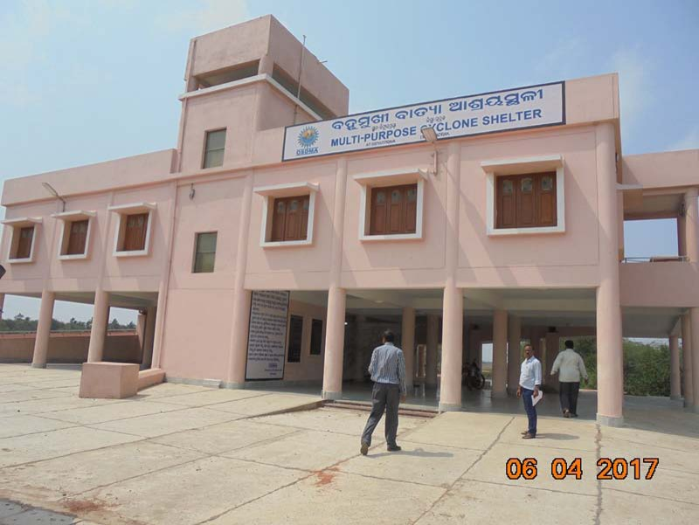
25 | Bhadrak | Eram | 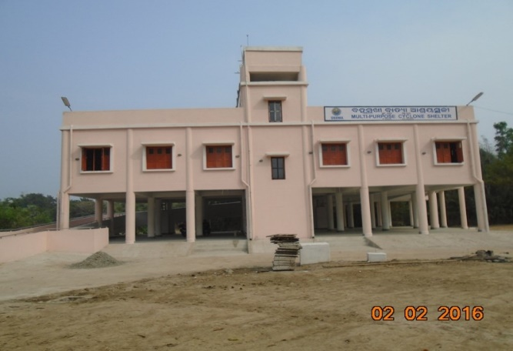
26 | Bhadrak | Radhakantapur | 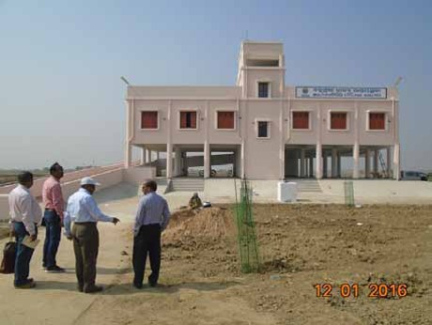
27 | Bhadrak | Badatilanchi | 