DETAILS OF COMPLETED MPCS UNDER NCRMP WORK
Sl. No. | Name of the District | Name of the Cyclone Shelters | Photographs of the MPCS
1 | Jajpur | Dhanmandal | 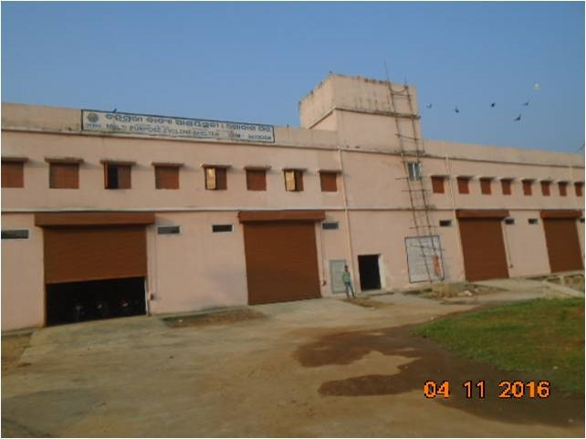
2 | Jajpur | J.K. Road | 