DETAILS OF COMPLETED MPCS UNDER NCRMP WORK
Sl. No. | Name of the District | Name of the Cyclone Shelters | Photographs of the MPCS
1 | Kendrapara | Kajalabandha | 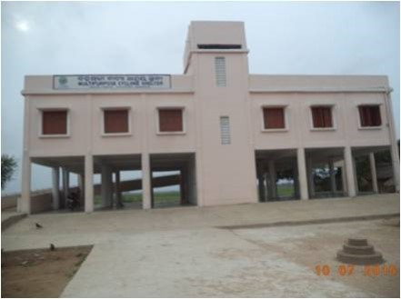
2 | Kendrapara | Bilikana | 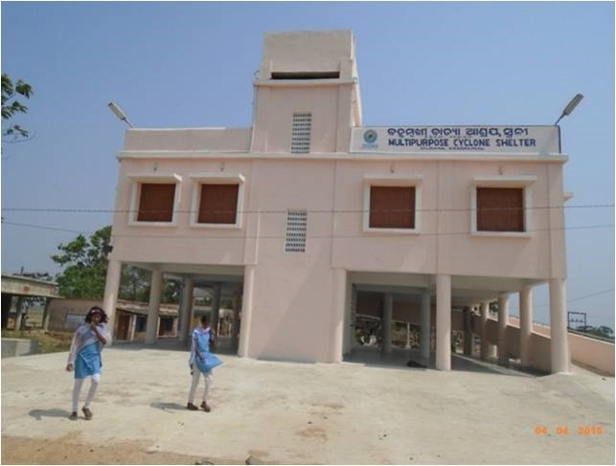
3 | Kendrapara | Satakuria | 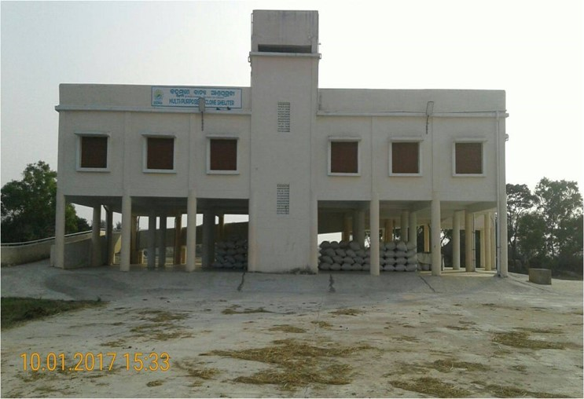
4 | Kendrapara | Pokharia | 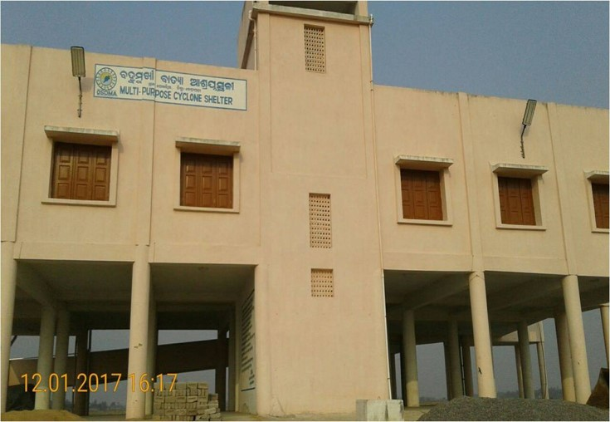
5 | Kendrapara | Baliganda | 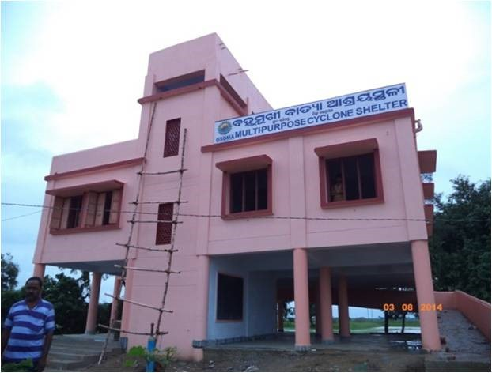
6 | Kendrapara | GokhaKhati | 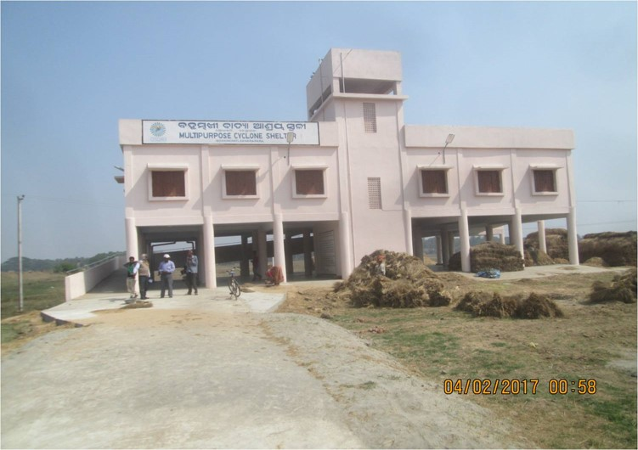
7 | Kendrapara | Radia | 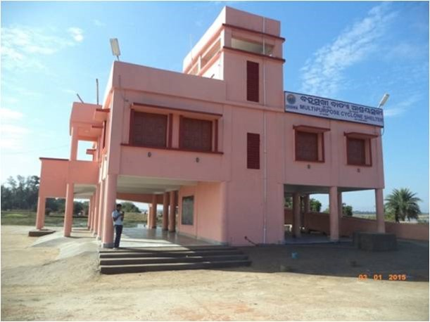
8 | Kendrapara | Pitapata | 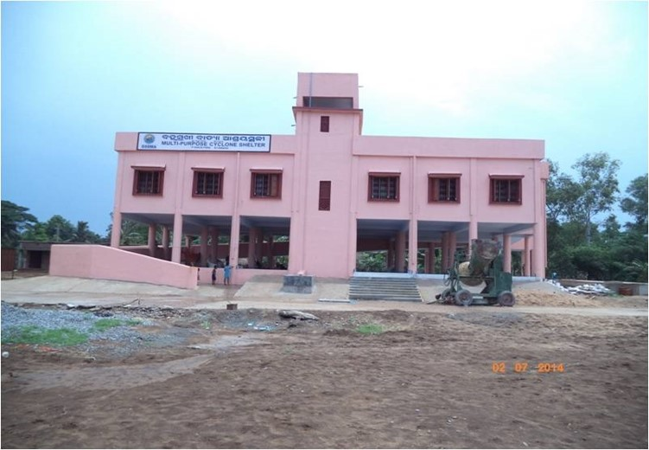
9 | Kendrapara | Kanpur | 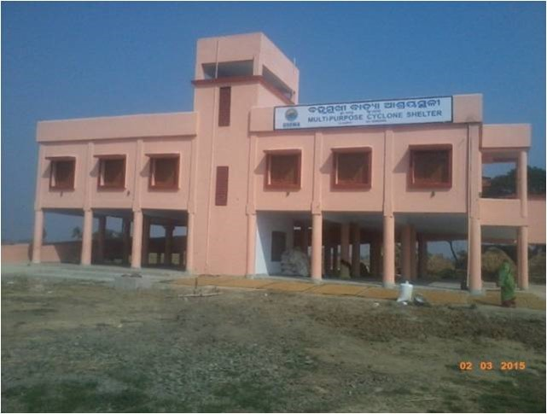
10 | Kendrapara | Tentulikandha | 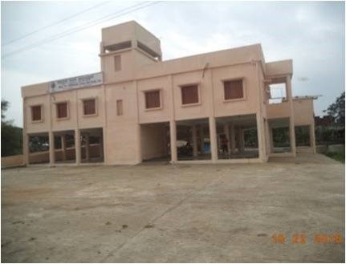
11 | Kendrapara | Bagagahan | 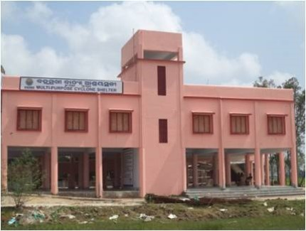
12 | Kendrapara | Kajalpatia | 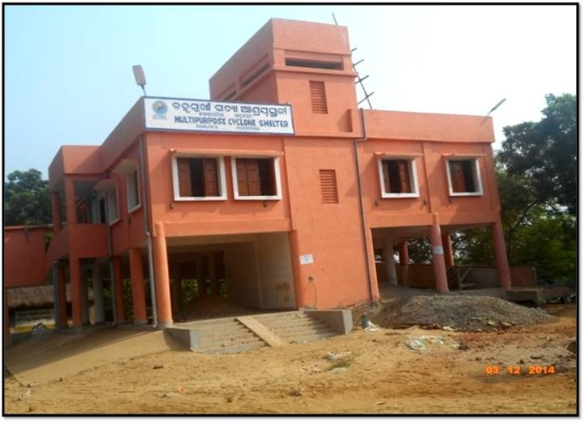
13 | Kendrapara | Jamboo | 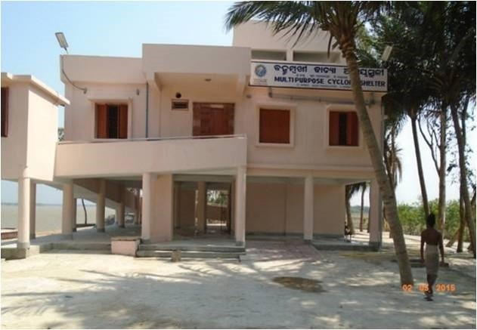
14 | Kendrapara | TantiapalSasan | 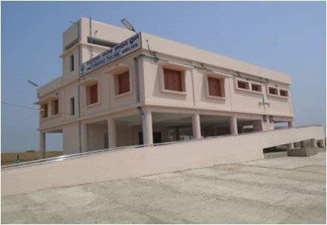
15 | Kendrapara | Janara | 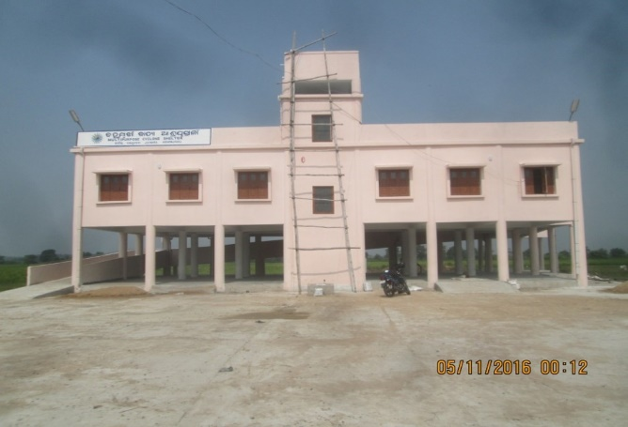
16 | Kendrapara | Kanshpal | 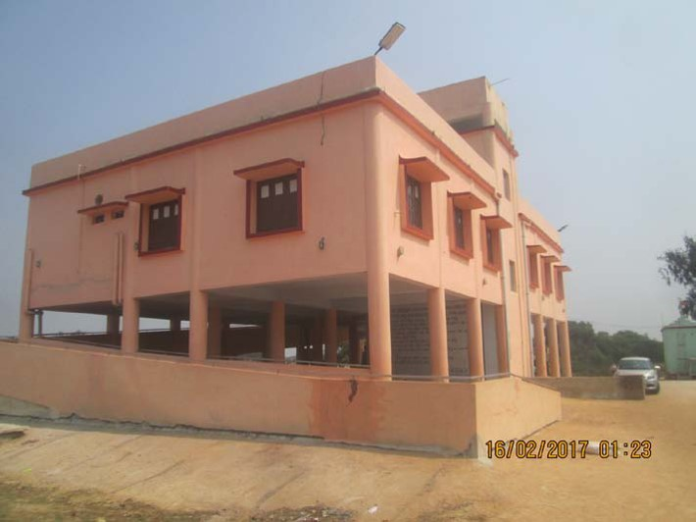
17 | Kendrapara | Badheipur | 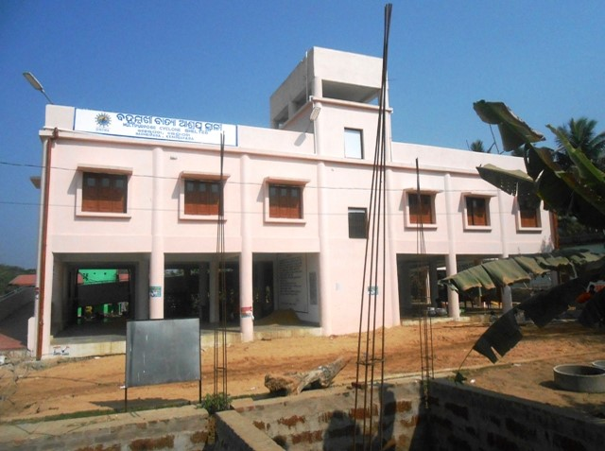
18 | Kendrapara | Koilipur | 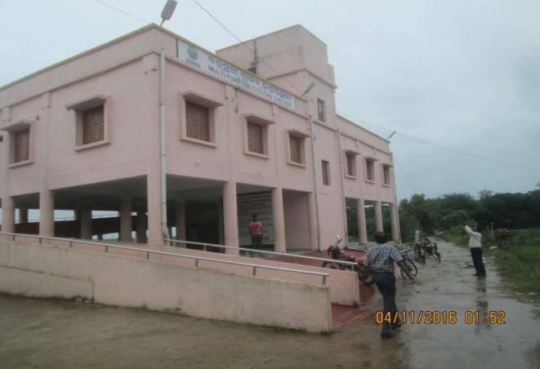
19 | Kendrapara | Laxminarayanpur | 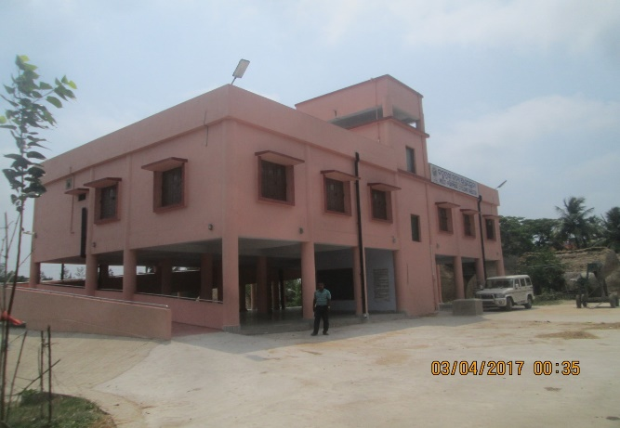
20 | Kendrapara | Padmanavpur | 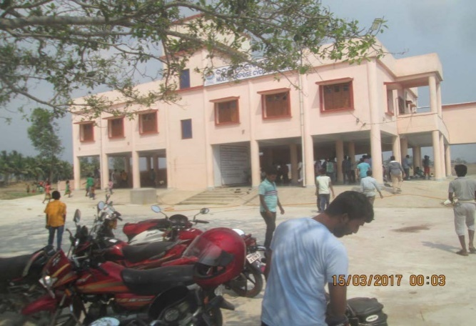
21 | Kendrapara | Dangamala (Khamarsahi) | 