DETAILS OF COMPLETED MPCS UNDER NCRMP
Sl. No. | District | Name of the MPCS | Photograph of the MPCS
1 | Khordha | Binjhala | 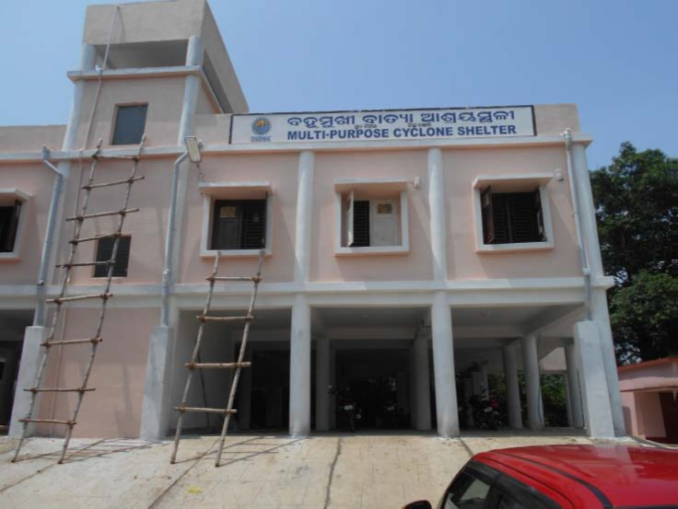
2 | Khordha | Narendrapur | 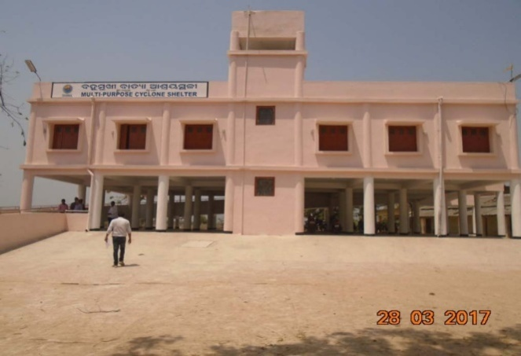
3 | Khordha | Haichandanpur | 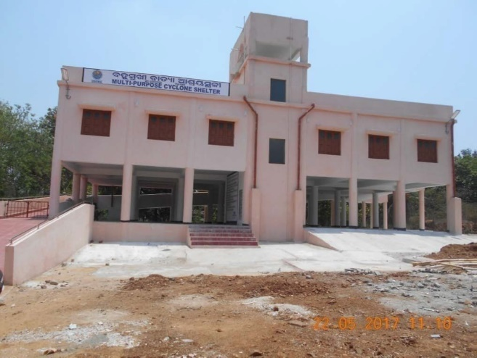
4 | Khordha | Kulei | 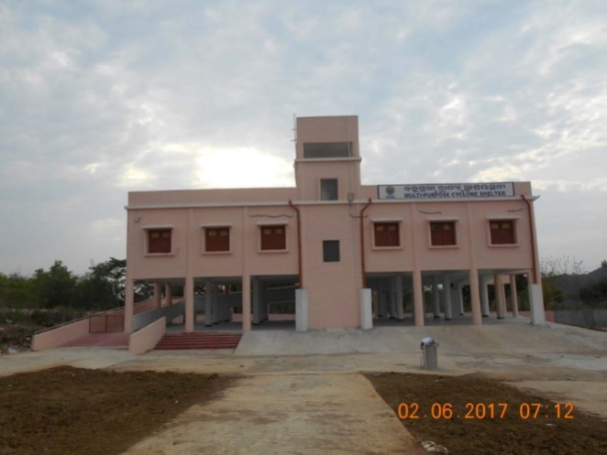
5 | Khordha | Moramori | 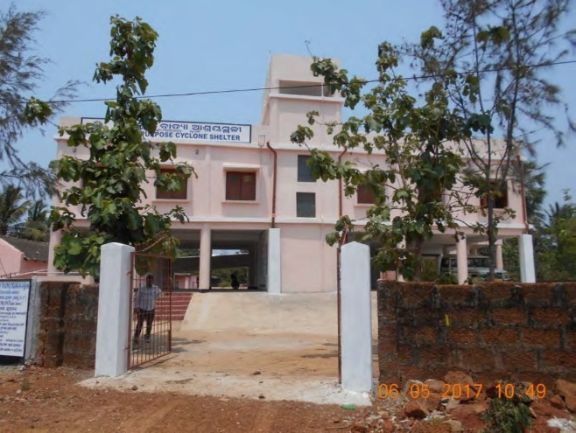
6 | Khordha | Punjima Sasan | 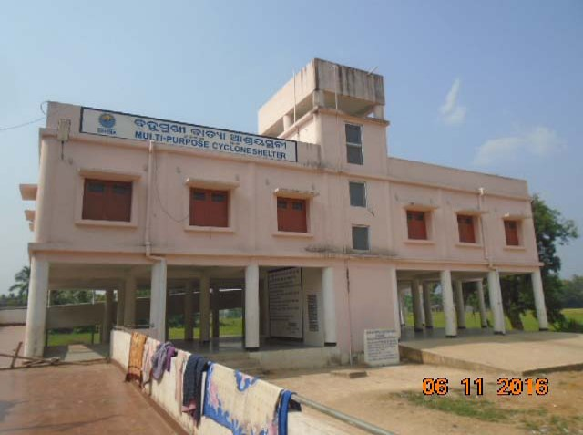
7 | Khordha | Dhuanla | 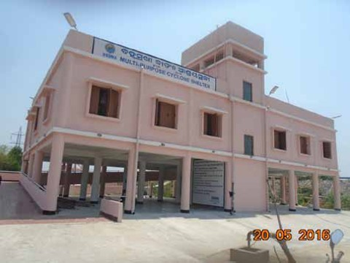
8 | Khordha | Boriasahi (Nimeimala) | 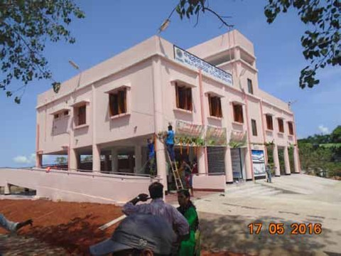
9 | Khordha | Mandia Merusahi | 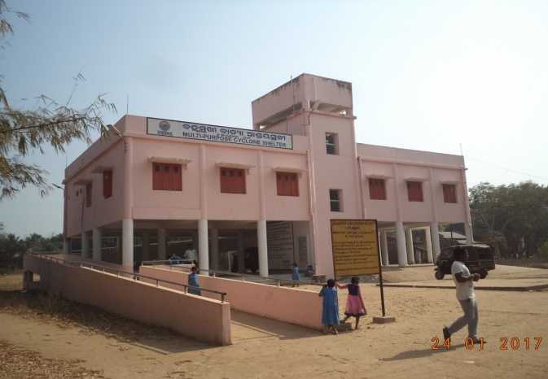
10 | Khordha | Baradihi | 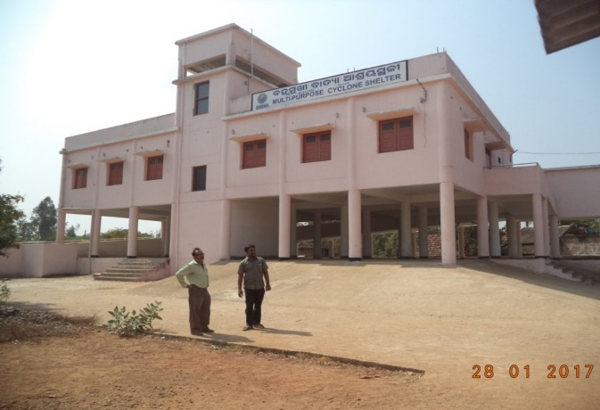
11 | Khordha | Hariharpur | 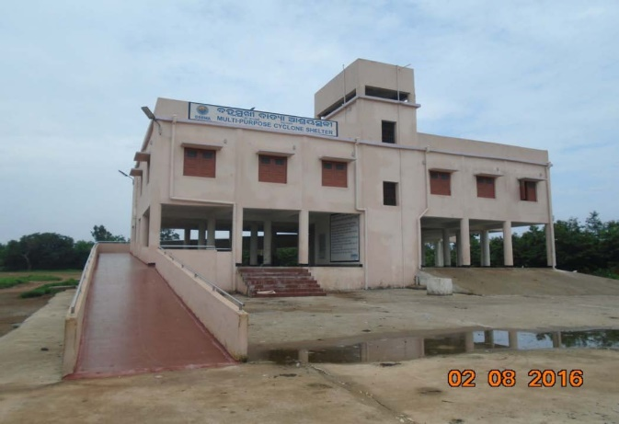
12 | Khordha | Bhagabatipur | 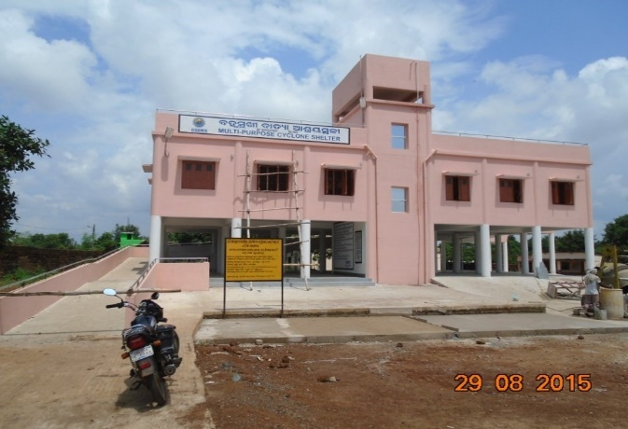
13 | Khordha | Manasinghapur | 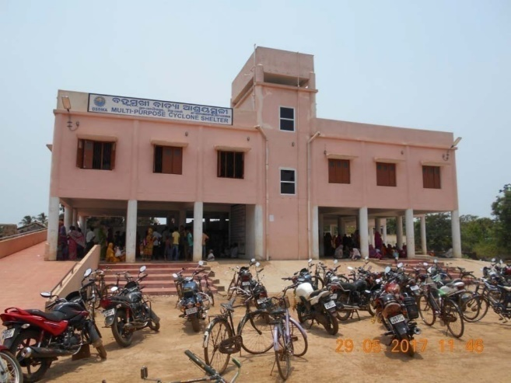
14 | Khordha | Sorona | 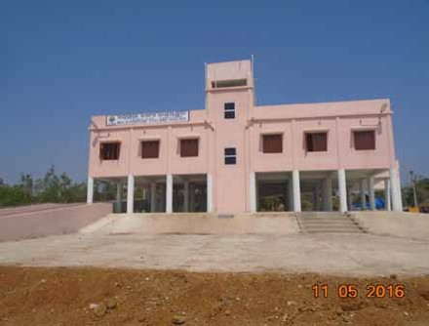
15 | Khordha | Karatiasahi | 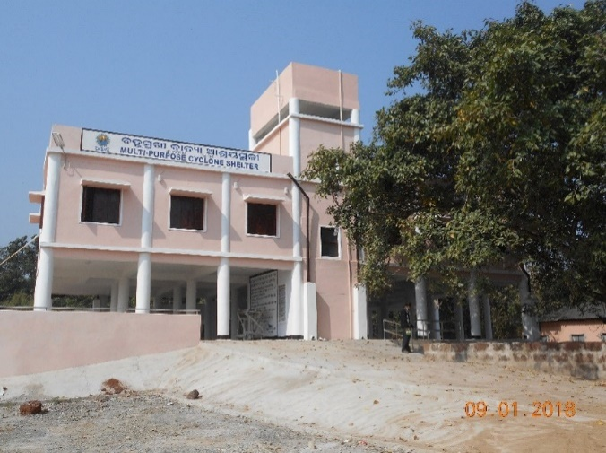
16 | Khordha | Mangalijodi | 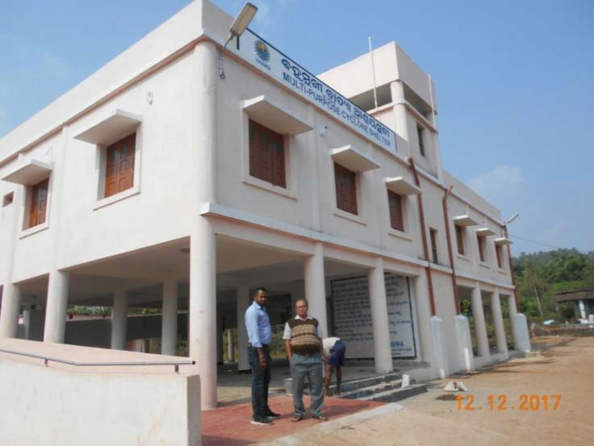
17 | Khordha | Parabala | 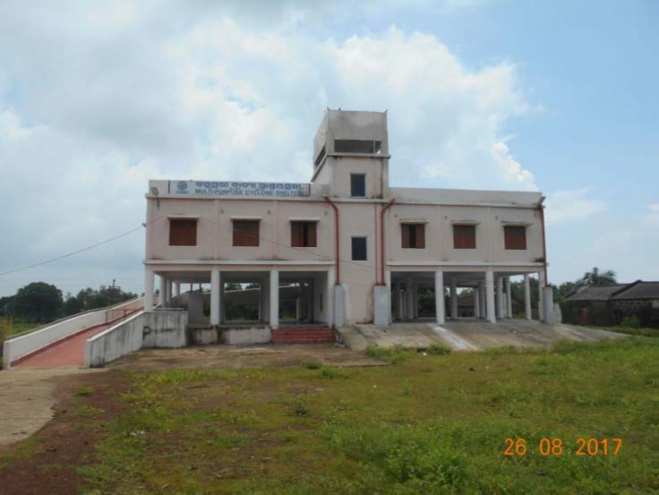
18 | Khordha | Abhimanpur | 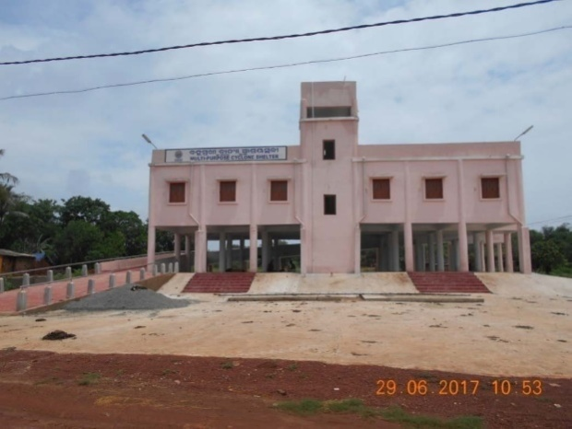
19 | Khordha | Jhati Nuagaon | 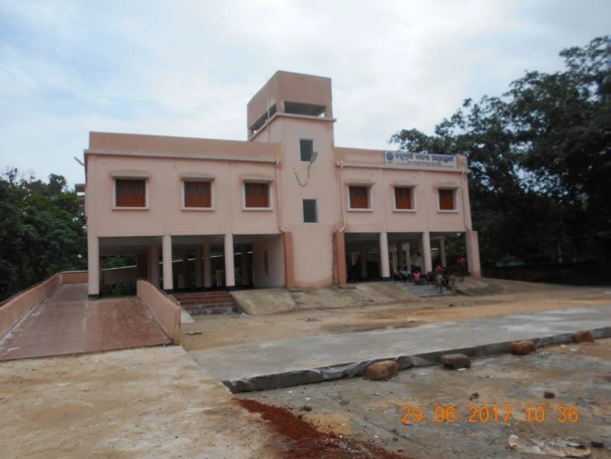
20 | Khordha | Kantalbai | 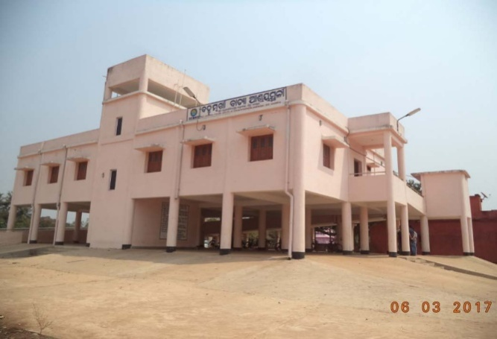
21 | Khordha | Ramachandrapur | 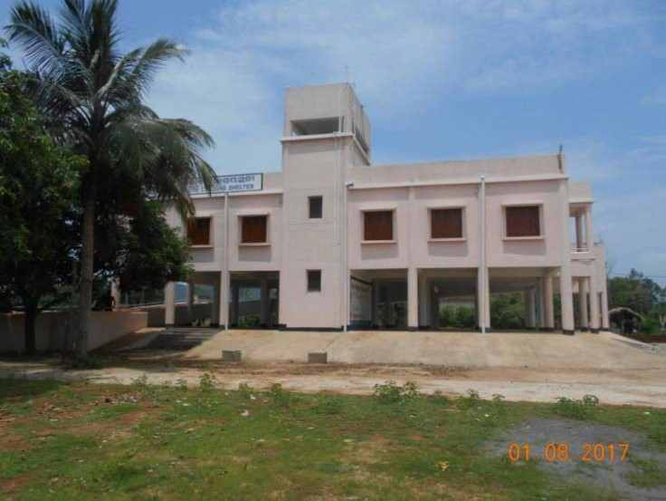
22 | Khordha | Nuagarh | 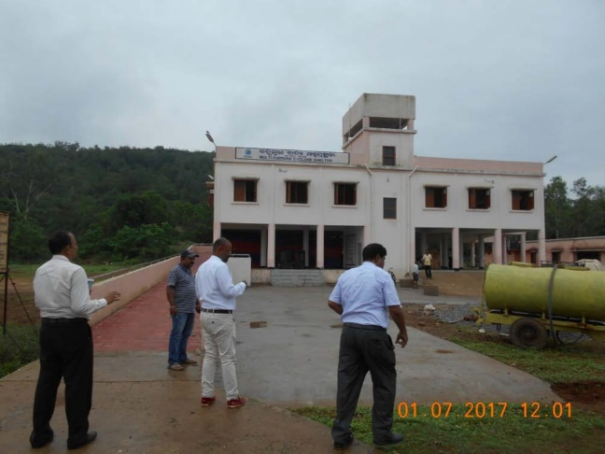
23 | Khordha | Jatani | 